PROJECT 1: Inter-VLAN Routing using Router-on-a-Stick (RoS)

# Project Overview

The goal of this project is to segment a network into different VLANs (HR, Finance, IT) using a switch and a router. Router-on-a-Stick will be used to enable inter-VLAN routing, where the router handles communication between VLANs.

# Devices, IP Addresses, and Cables

| Device | Type | Name |
| --- | --- | --- |
| Router0 | Cisco 2811 | Router |
| Switch0 | Cisco 2960 | Switch |
| PC0 | Cisco PC | HR |
| PC1 | Cisco PC | Finance |
| PC2 | Cisco PC | IT |

## IP Addresses:

1. **HR PC**: 192.168.10.10/24

* Default Gateway: 192.168.10.1

1. **Finance PC**: 192.168.20.10/24

* Default Gateway: 192.168.20.1

1. **IT PC**: 192.168.30.10/24

* Default Gateway: 192.168.30.1

## Cables and Interfaces:

A Copper Straight-through cable was used to connect all the devices.

1. Router (FastEthernet0/0) to Switch (FastEthernet0/4)
2. Switch (FastEthernet0/1) to HR (FastEthernet0)
3. Switch (FastEthernet0/2) to Finance (FastEthernet0)
4. Switch (FastEthernet0/3) to IT (FastEthernet0)

# Network Topology

## Topology Version 1:

The interface between the router and the switch is shown in the image below. The red triangles indicated this. In the following steps, I showed how to fix this issue.

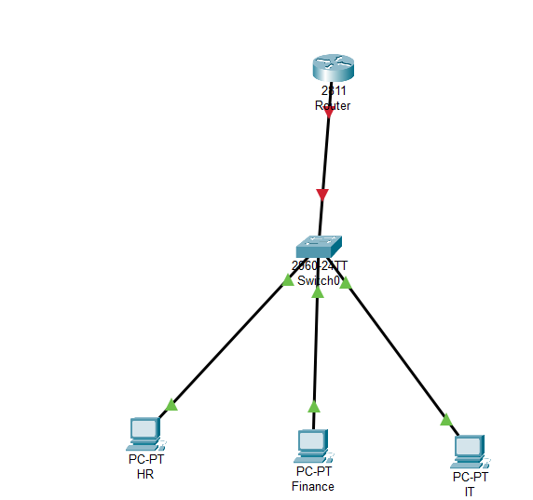

## Correction:

I fixed the error in the Router CLI.

Commands Used

Router> en

Router# config

Router(config)# interface FastEthernet0/0

Router(config-if)# no shutdown

Router(config-if)# exit

Screenshot of Output

## Topology Version 2:

In the image below, the interface is no up.

# Implementation Steps

## Step 1: Configure VLANs

I then created VLANs on the switch for HR, Finance, and IT departments.

Commands Used

Switch> en

Switch# config

Switch(config)# vlan 10

Switch(config-vlan)# name HR

Switch(config-vlan)# exit

Switch(config)# vlan 20

Switch(config-vlan)# name Finance

Switch(config-vlan)# exit

Switch(config)# vlan 30

Switch(config-vlan)# name IT

Switch(config-vlan)# exit

Screenshot of Output

## Step 2: Assign VLANs to Switch Ports

The VLANs were then assigned to the switch port.

Commands Used

Switch> en

Switch# config

Switch(config)# interface FastEthernet0/1

Switch(config-if)# switchport mode access

Switch(config-if)# switchport access vlan 10

Switch(config-if)# exit

Switch(config)# interface FastEthernet0/2

Switch(config-if)# switchport mode access

Switch(config-if)# switchport access vlan 20

Switch(config-if)# exit

Switch(config)# interface FastEthernet0/3

Switch(config-if)# switchport mode access

Switch(config-if)# switchport access vlan 30

Switch(config-if)# exit

Screenshot of Output

## Step 3: Router-on-a-Stick

The Subinterfaces were configured on the router. Each Subinterface was enabled on the router for each VLAN. This allows the router to route traffic between VLANs.

Commands Used

Router> en

Router# config

Router(config)# interface FastEthernet0/0.10

Router(config-if)# encapsulation dot1Q 10

Router(config-if)# ip address 192.168.10.1 255.255.255.0

Router(config-if)# exit

Router(config)# interface FastEthernet0/0.20

Router(config-if)# encapsulation dot1Q 20

Router(config-if)# ip address 192.168.20.1 255.255.255.0

Router(config-if)# exit

Router(config)# interface FastEthernet0/0.30

Router(config-if)# encapsulation dot1Q 30

Router(config-if)# ip address 192.168.30.1 255.255.255.0

Router(config-if)# exit

Commands Used

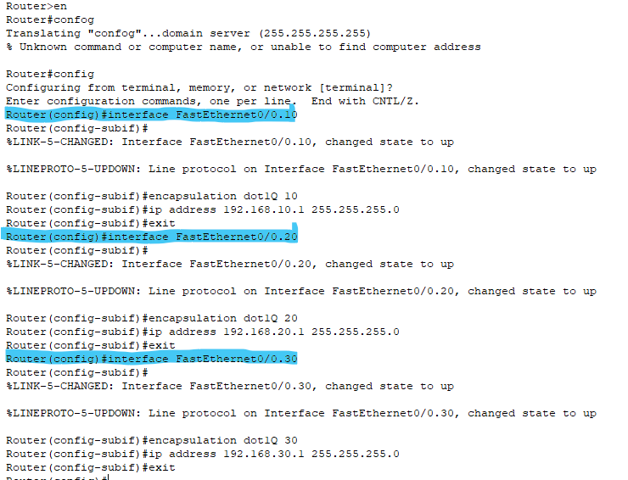

## Step 4: Configure Trunking on the Switch Port

In this step, I configured the trunking between the switch and the router to allow VLAN traffic to pass between the two devices.

Commands Used

Switch> en

Switch# config

Switch(config)# interface FastEthernet0/4

Switch(config-if)# switchport mode trunk

Switch(config-if)# exit

Commands Used

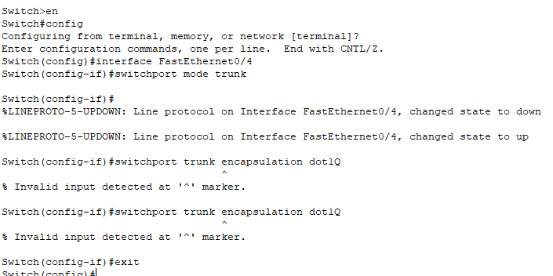

## Step 5: Configure DHCP Pools on the Router

DHCP pools were then created for each VLAN to dynamically assign IP addresses to PCs in each VLAN.

Commands Used

Router> en

Router# config

Router(config)# ip dhcp pool HR

Router(dhcp-config)# network 192.168.10.0 255.255.255.0

Router(dhcp-config)# default-router 192.168.10.1

Router(dhcp-config)# dns-server 8.8.8.8

Router(dhcp-config)# exit

Router(config)# ip dhcp pool Finance

Router(dhcp-config)# network 192.168.20.0 255.255.255.0

Router(dhcp-config)# default-router 192.168.20.1

Router(dhcp-config)# dns-server 8.8.8.8

Router(dhcp-config)# exit

Router(config)# ip dhcp pool IT

Router(dhcp-config)# network 192.168.30.0 255.255.255.0

Router(dhcp-config)# default-router 192.168.30.1

Router(dhcp-config)# dns-server 8.8.8.8

Router(dhcp-config)# exit

Screenshot of Output

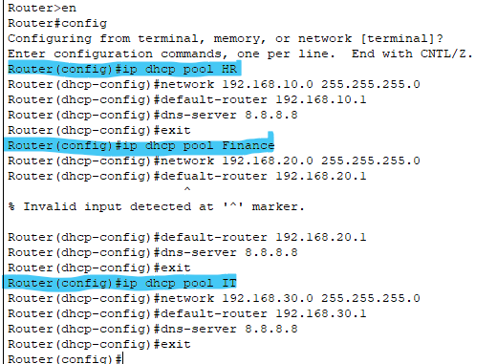

## Step 8: Exclude Router’s IP from DHCP Pool

The router’s IP addresses were excluded from the DHCP pool to avoid assigning them to PCs.

Commands Used

Router> en

Router# config

Router(config)# ip dhcp excluded-address 192.168.10.1

Router(config)# ip dhcp excluded-address 192.168.20.1

Router(config)# ip dhcp excluded-address 192.168.30.1

Router(config)# exit

Screenshot of Output

## Step 9: Set PCs

**Configure PCs:**

Each of the PCs was configured to use DHCP for the IP address assignment. Within each PC, I set the IP configuration to Obtain an IP address automatically (DHCP) in the Desktop > IP Configuration menu.

Screenshot of Output

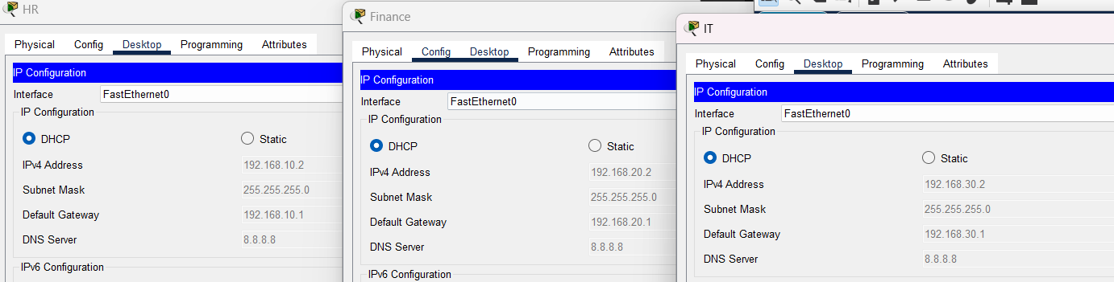

## Step 10: Test DHCP and Connectivity

I then verified the IP address assignments on each PC.

Command Used

C:> ipconfig

Screenshot of Output

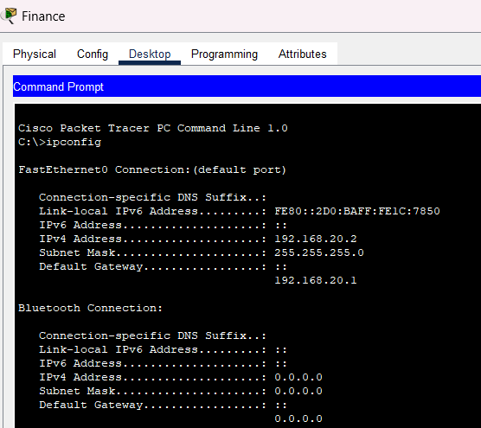

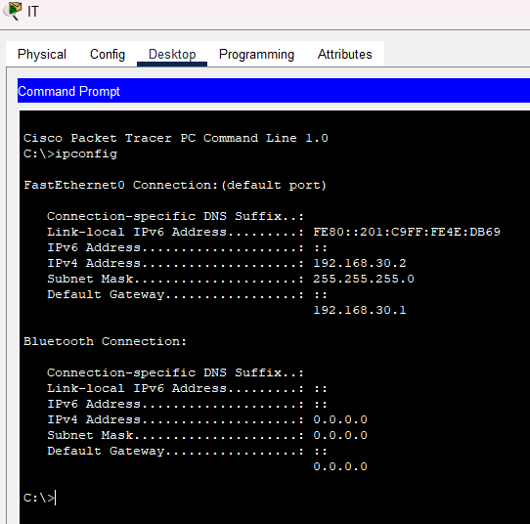

**Test Connectivity:**

I then tested the connectivity between the PCs.

1. **HR PC:** 192.168.10.20
2. **Finance PC:** 192.168.20.20
3. **IT PC:** 192.168.30.20

**HR PC:**

Commands Used

C:> ping 192.168.20.20

C:> ping 192.168.30.20

Screenshot of Output

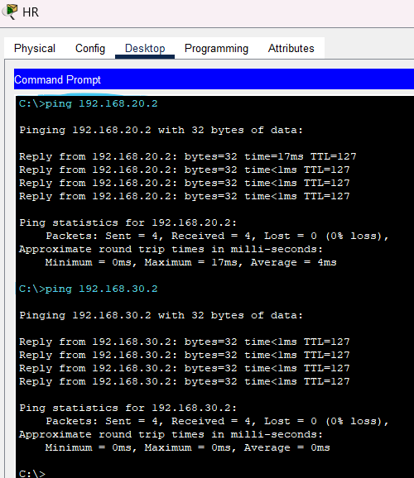

**Finance PC:**

Commands Used

C:> ping 192.168.10.20

C:> ping 192.168.30.20

Screenshot of Output

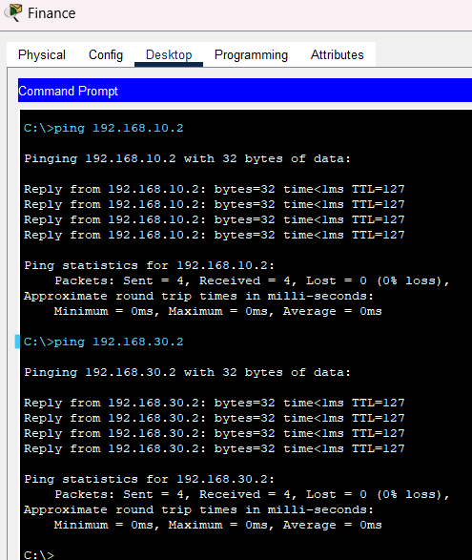

**IT PC:**

Commands Used

C:> ping 192.168.10.20

C:> ping 192.168.20.20

Screenshot of Output

